FITNESS TRENDS AND WORKOUT PREFERENCES ANALYSIS

Nayan Bisessar   
*Comp 3125*

*Abstract—This report explores fitness trends and workout preferences using data analysis to draw meaningful conclusions. Key insights include the popularity of various workout types, the seasonal impact on fitness habits, mood differences between active and inactive individuals, the role of personal trainers in gym consistency and general trends in exercises.*

Keywords—fitness trends, seasonal impact, mood analysis, gym attendance

# Introduction

This project investigates trends in fitness and workout preferences by analyzing key questions such as the most popular workout types, seasonal impacts on gym attendance, mood differences, and consistency of exercises. The motivation for this study stems from my love for fitness and health. I have been going to the gym for about three years now and thought it would be interesting to find statistics. This report builds upon on existing data by integrating detailed data analysis and visualization to draw meaningful conclusions.

# Datasets

## megaGymdataset

Contains columns like workout types, exercise durations, and associated popularity. This dataset was found on Kaggle., hence making it credible.

## Fitbit Datasets

Includes step counts, calories burned, and activity dates for activity tracking. This dataset can be found on Kaggle and has around twenty csv files, but we only used dailyActivity_merged. The other datasets had useful information, but I deemed them unnecessary to answer my questions.

## 25 Datasets

Includes step counts, calories burned, and activity dates for activity tracking like the Fitbit dataset but includes a value for “mood”. This dataset was found on Kaggle.

## Gym_membership Datasets

Tracks membership status, time spent in the gym, and personal trainer usage. This dataset was found on Kaggle.

# Methodology

**The entire analysis was conducted using Google Colab with the Python libraries pandas and matplotlib for data manipulation and visualization.**

## Data Preprocessing

* Converted dates into datetime objects.
* Merged datasets with similar columns.
* Altered columns and created new ones such as “season” and “exercise type.”

## Visualization

* Bar charts and grouped bar charts for popularity and comparisons.
* Seasonal trends represented with grouped averages.

## Analytical

Classification by using Boolean filtering to determine between active/inactive users.

# Results

## Popular Workout Types

#### Strength training emerged as the dominant workout type, with significantly higher participation compared to other categories.

## Seasonal Trends

Spring recorded the highest average steps and calories burned, likely due to pre-summer fitness goals, unfortunately I found no data for summer. 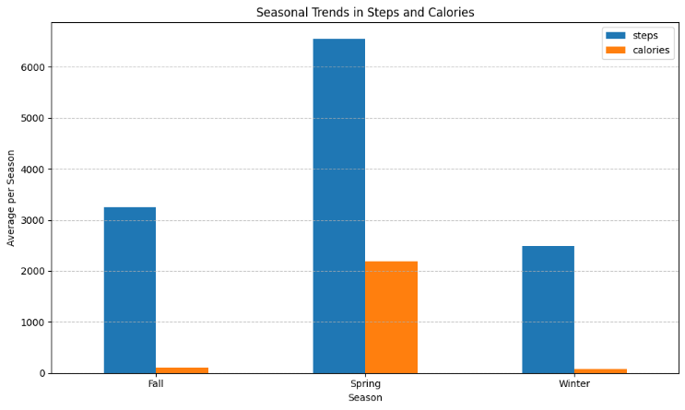

## Mood Differences

#### Active individuals consistently reported higher mood scores compared to inactive individuals, even when looking at some outside factors regarding health.

## Consistency Trends

Light activities like casual walking exhibited higher consistency compared to more intense activities. 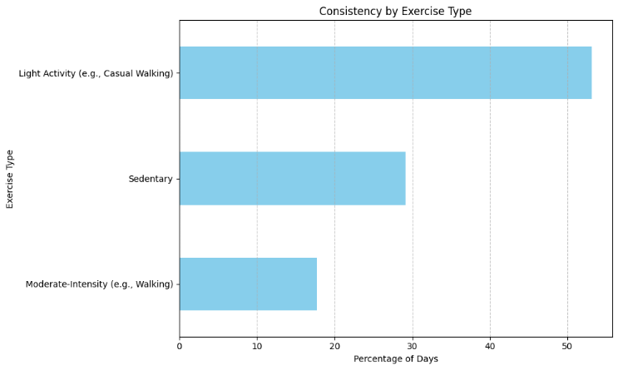

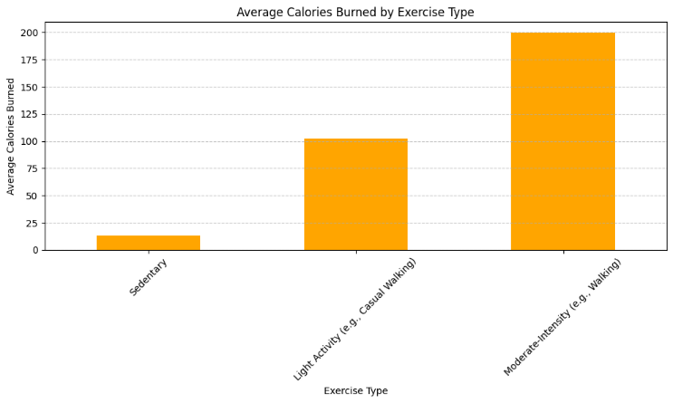

# Discussion

While this project provided valuable insights into fitness trends and workout preferences, a primary weakness was the scope of the datasets. For example, the data reflects activity trends from a limited demographic, which does not generalize well to a global audience. Also, the datasets rely on self-reported mood scores and step counts, which means that it could be biased or influenced by other factors. Users could overestimate their activity levels or inaccurately report their mood. I believe that I should better clean my data and find even more to accurately draw conclusions. Lastly, while seasonal trends were analyzed, external factors such as local weather conditions and events like the pandemic were not accounted for.

# Conclusion

This project analyzed fitness trends and workout preferences, showings trends such as the dominance of strength training, the positive correlation between activity levels and mood, and the impact of personal trainers on gym consistency. Seasonal trends are highlighted the significant influence of spring on fitness activities, driven by what we can assume are pre-summer fitness goals. These findings emphasize the importance of tailored fitness programs and their potential to improve mental and physical well-being. Also, understanding these trends can help gyms and fitness companies, design more effective interventions and programs. By addressing the limitations outlined in the discussion, we can further enhance the applicability and reliability of these results in the real world.

.

##### References

1. T. Adam, “Gym Membership Dataset,” *Kaggle.com*, 2024. https://www.kaggle.com/datasets/ka66ledata/gym-membership-dataset?resource=download
2. ‌“FitBit Fitness Tracker Data,” www.kaggle.com. https://www.kaggle.com/datasets/arashnic/fitbit
3. ‌“Gym Exercise Dataset,” www.kaggle.com. https://www.kaggle.com/datasets/niharika41298/gym-exercise-data
4. “Fitness Trends Dataset,” *www.kaggle.com*. https://www.kaggle.com/datasets/aroojanwarkhan/fitness-data-trends